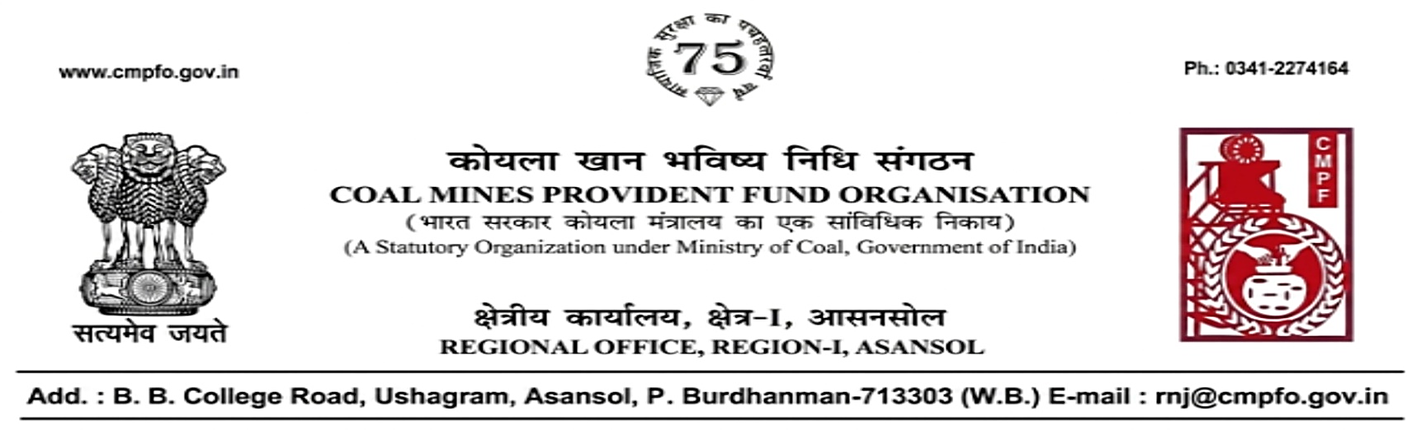
CPF/118/Misc./L.C.-Req./R-I/ASN/ Date-18/08/2026

To
The Regional Commissioner
Coal Mines Provident Fund
Mcl Complex Anandvihar
Po-Jagruti Vihar
Sambalpur
Odisha768020

Sub:- Inter Regional Transfer of Ledger Card.

Ref:- AGT/JNR/JPC/HR/CMPF/2026/2042 dated 09-08-2026

Sir,
In view of the revised Procedures prescribed in Procedure Office Order No-35, Dated 12.02.1975 of CMPF Commissioner, Dhanbad, it is stated that the Ledger Cards of the following members along with Declaration in Form A, PS-3 & PS-4 and details of pension contribution may kindly be forwarded to this office as the member(s) is/are working in this region.
It may kindly be ensured that the posting in the Ledger Cards have been made/updated for the periods the member was working in this Region.
In case, the Ledger Card(s) already transferred from your Region, the Region to whom transferred, indicating the details of transfer and your letter number and date be intimated.

SL. No | Name of the Member | CMPF A/C No | Name of the colliery where the member worked in your Region and period of work done | Name of the colliery where the member is currently working in this Region
1 | Shri Joydev Roy | RNJ/38/2395 | Talcher Colliery, Talcher Area (MCL) Period- Sep-2007 to Des2012  Lingaraj O.C.P., Lingaraj Area (MCL) Period- Dec-2012 to March-2018 | Jhanjra Project Colliery, Jhanjra Area (RNJ/38 & 40)
Yours faithfully,

(Ajay Kumar Singh) Regional Commissioner - I

